Blowfish Algorithm

Aim :
To write a program that encrypt input string by using SecretKey of the following algorithms, and then decrypt the encrypted string and compare the decrypted string with the input string:

Code:

// Program to encrypt and decrypt the string using Blowfish algorithm and Secret Key

import java.security.*;
import javax.crypto.*;
import java.security.spec.*;
import javax.crypto.spec.*;

public class Blowfish
{
Cipher enCipher;
Cipher deCipher;

public Blowfish(SecretKey key, String algorithm)
{
try
{
enCipher = Cipher.getInstance(algorithm);
deCipher = Cipher.getInstance(algorithm);

enCipher.init(Cipher.ENCRYPT_MODE, key);
deCipher.init(Cipher.DECRYPT_MODE, key);
}
catch(Exception e)
{
System.out.println(e);
}
}

public String encrypt(String str)
{
try
{
byte utf8[] = str.getBytes("UTF8");
byte en[] = enCipher.doFinal(utf8);

return new sun.misc.BASE64Encoder().encode(en);
}
catch(Exception e)
{
System.out.println(e);
}

return null;
}

public String decrypt(String str)
{
try
{
byte de[] = new sun.misc.BASE64Decoder().decodeBuffer(str);
byte utf8[] = deCipher.doFinal(de);

return new String(utf8, "UTF8");
}
catch(Exception e)
{
System.out.println(e);
}

return null;
}

public static void testUsingSecretKey()
{
try
{
String secretString = "Msccs";

SecretKey blowfishKey = KeyGenerator.getInstance("Blowfish").generateKey();

Blowfish blowfishEncrypter = new Blowfish(blowfishKey, blowfishKey.getAlgorithm());

String blowfishEncrypted = blowfishEncrypter.encrypt(secretString);

String blowfishDecrypted = blowfishEncrypter.decrypt(blowfishEncrypted);

System.out.println("\n" + blowfishKey.getAlgorithm() + " Encryption alogrithm");
System.out.println("Original String : " + secretString);
System.out.println("Encrypted String : " + blowfishEncrypted);
System.out.println("Decrypted String : " + blowfishDecrypted);

}
catch(Exception e)
{
System.out.println(e);
}
}

public static void main(String a[])
{
testUsingSecretKey();
}
}

Output:
D:\TYNS>java Blowfish

Blowfish Encryption alogrithm
Original String : Msccs
Encrypted String : w0XuOVdGi8I=
Decrypted String : Msccs

Class Diagram:

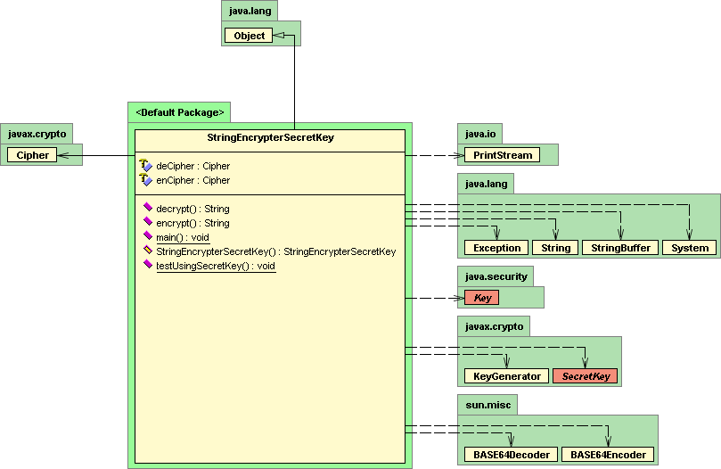

Interface Used:

public interface SecretKey extends Key
A secret (symmetric) key. This interface contains no methods or constants. Its only purpose is to group (and provide type safety for) secret keys.

Provider implementations of this interface must overwrite the equals and hashCode methods inherited from java.lang.Object, so that secret keys are compared based on their underlying key material and not based on reference.

Class Used:

public class Cipher extends Object
This class provides the functionality of a cryptographic cipher for encryption and decryption. It forms the core of the Java Cryptographic Extension (JCE) framework. In order to create a Cipher object, the application calls the Cipher's getInstance method, and passes the name of the requested transformation to it. Optionally, the name of a provider may be specified.

A transformation is a string that describes the operation (or set of operations) to be performed on the given input, to produce some output. A transformation always includes the name of a cryptographic algorithm (e.g., DES), and may be followed by a feedback mode and padding scheme.

A transformation is of the form:
- "algorithm/mode/padding" or
- "algorithm"

public class KeyGenerator extends Object
This class provides the functionality of a (symmetric) key generator. Key generators are constructed using one of the getInstance class methods of this class. KeyGenerator objects are reusable, i.e., after a key has been generated, the same KeyGenerator object can be re-used to generate further keys.

There are two ways to generate a key: in an algorithm-independent manner, and in an algorithm-specific manner. The only difference between the two is the initialization of the object:

- Algorithm-Independent Initialization
All key generators share the concepts of a keysize and a source of randomness. There is an init method in this KeyGenerator class that takes these two universally shared types of arguments. There is also one that takes just a keysize argument, and uses the SecureRandom implementation of the highest-priority installed provider as the source of randomness (or a system-provided source of randomness if none of the installed providers supply a SecureRandom implementation), and one that takes just a source of randomness.

Since no other parameters are specified when you call the above algorithm-independent init methods, it is up to the provider what to do about the algorithm-specific parameters (if any) to be associated with each of the keys.

- Algorithm-Specific Initialization
For situations where a set of algorithm-specific parameters already exists, there are two init methods that have an AlgorithmParameterSpec argument. One also has a SecureRandom argument, while the other uses the SecureRandom implementation of the highest-priority installed provider as the source of randomness (or a system-provided source of randomness if none of the installed providers supply a SecureRandom implementation).

Method used:

public static final KeyGenerator getInstance(String algorithm)
throws NoSuchAlgorithmException
Generates a KeyGenerator object for the specified algorithm. If the default provider package provides an implementation of the requested key generator, an instance of KeyGenerator containing that implementation is returned. If the requested key generator is not available in the default provider package, other provider packages are searched.

public final SecretKey generateSecret(KeySpec keySpec) throws InvalidKeySpecException
Generates a SecretKey object from the provided key specification (key material).

public static final Cipher getInstance(String transformation)
throws NoSuchAlgorithmException, NoSuchPaddingException
Generates a Cipher object that implements the specified transformation. If the default provider package supplies an implementation of the requested transformation, an instance of Cipher containing that implementation is returned. If the transformation is not available in the default provider package, other provider packages are searched.

public final void init(int opmode, Key key, AlgorithmParameters params) throws InvalidKeyException, InvalidAlgorithmParameterException
Initializes this cipher with a key and a set of algorithm parameters. The cipher is initialized for one of the following four operations: encryption, decryption, key wrapping or key unwrapping, depending on the value of opmode.

If this cipher requires any algorithm parameters and params is null, the underlying cipher implementation is supposed to generate the required parameters itself (using provider-specific default or random values) if it is being initialized for encryption or key wrapping, and raise an InvalidAlgorithmParameterException if it is being initialized for decryption or key unwrapping. The generated parameters can be retrieved using getParameters or getIV (if the parameter is an IV).

If this cipher (including its underlying feedback or padding scheme) requires any random bytes (e.g., for parameter generation), it will get them using the SecureRandom implementation of the highest-priority installed provider as the source of randomness. (If none of the installed providers supply an implementation of SecureRandom, a system-provided source of randomness will be used.)

public final byte[] doFinal(byte[] input) throws IllegalBlockSizeException, BadPaddingException
Encrypts or decrypts data in a single-part operation, or finishes a multiple-part operation. The data is encrypted or decrypted, depending on how this cipher was initialized.

The bytes in the input buffer, and any input bytes that may have been buffered during a previous update operation, are processed, with padding (if requested) being applied. The result is stored in a new buffer.

Upon finishing, this method resets this cipher object to the state it was in when previously initialized via a call to init. That is, the object is reset and available to encrypt or decrypt (depending on the operation mode that was specified in the call to init) more data.

